**DSA Lab Practice Exercise 1**

**Name:** Wilson Vidyut Doloy

**Reg No:** 19BCE1603

Q2.

Find MST for the below Graph using PRIM’s and KRUSKAL’s Algorithm

#include<stdio.h>

#define MAX 30

typedef struct edge

{

int u,v,w;

}edge;

typedef struct edgelist

{

edge data[MAX];

int n;

}edgelist;

edgelist elist;

int G[MAX][MAX],n;

edgelist spanlist;

void kruskal();

int find(int belongs[],int vertexno);

void union1(int belongs[],int c1,int c2);

void sort();

void print();

void main()

{

int i,j,total_cost;

printf("\nEnter number of vertices:");

scanf("%d",&n);

printf("\nEnter the adjacency matrix:\n");

for(i=0;i<n;i++)

for(j=0;j<n;j++)

scanf("%d",&G[i][j]);

kruskal();

print();

}

void kruskal()

{

int belongs[MAX],i,j,cno1,cno2;

elist.n=0;

for(i=1;i<n;i++)

for(j=0;j<i;j++)

{

if(G[i][j]!=0)

{

elist.data[elist.n].u=i;

elist.data[elist.n].v=j;

elist.data[elist.n].w=G[i][j];

elist.n++;

}

}

sort();

for(i=0;i<n;i++)

belongs[i]=i;

spanlist.n=0;

for(i=0;i<elist.n;i++)

{

cno1=find(belongs,elist.data[i].u);

cno2=find(belongs,elist.data[i].v);

if(cno1!=cno2)

{

spanlist.data[spanlist.n]=elist.data[i];

spanlist.n=spanlist.n+1;

union1(belongs,cno1,cno2);

}

}

}

int find(int belongs[],int vertexno)

{

return(belongs[vertexno]);

}

void union1(int belongs[],int c1,int c2)

{

int i;

for(i=0;i<n;i++)

if(belongs[i]==c2)

belongs[i]=c1;

}

void sort()

{

int i,j;

edge temp;

for(i=1;i<elist.n;i++)

for(j=0;j<elist.n-1;j++)

if(elist.data[j].w>elist.data[j+1].w)

{

temp=elist.data[j];

elist.data[j]=elist.data[j+1];

elist.data[j+1]=temp;

}

}

void print()

{

int i,cost=0;

for(i=0;i<spanlist.n;i++)

{

printf("\n%d\t%d\t%d",spanlist.data[i].u,spanlist.data[i].v,spanlist.data[i].w);

cost=cost+spanlist.data[i].w;

}

printf("\n\nCost of the spanning tree=%d",cost);

}

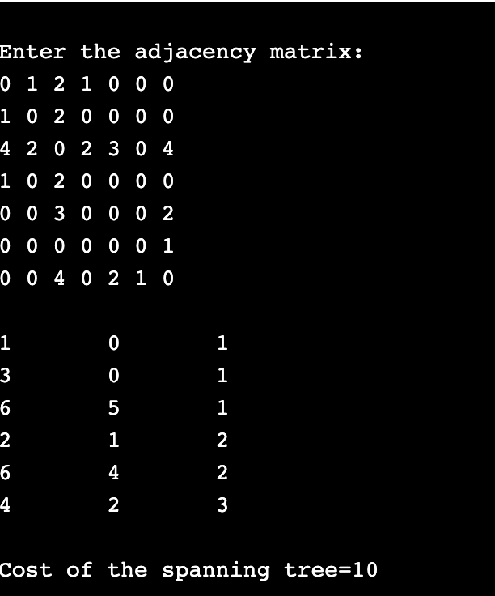

#include<stdio.h>

#include<stdlib.h>

#define infinity 9999

#define MAX 20

int G[MAX][MAX],spanning[MAX][MAX],n;

int prims();

int main()

{

int i,j,total_cost;

printf("Enter no. of vertices:");

scanf("%d",&n);

printf("\nEnter the adjacency matrix:\n");

for(i=0;i<n;i++)

for(j=0;j<n;j++)

scanf("%d",&G[i][j]);

total_cost=prims();

printf("\nspanning tree matrix:\n");

for(i=0;i<n;i++)

{

printf("\n");

for(j=0;j<n;j++)

printf("%d\t",spanning[i][j]);

}

printf("\n\nTotal cost of spanning tree=%d",total_cost);

return 0;

}

int prims()

{

int cost[MAX][MAX];

int u,v,min_distance,distance[MAX],from[MAX];

int visited[MAX],no_of_edges,i,min_cost,j;

for(i=0;i<n;i++)

for(j=0;j<n;j++)

{

if(G[i][j]==0)

cost[i][j]=infinity;

else

cost[i][j]=G[i][j];

spanning[i][j]=0;

}

distance[0]=0;

visited[0]=1;

for(i=1;i<n;i++)

{

distance[i]=cost[0][i];

from[i]=0;

visited[i]=0;

}

min_cost=0;

no_of_edges=n-1;

while(no_of_edges>0)

{

min_distance=infinity;

for(i=1;i<n;i++)

if(visited[i]==0&&distance[i]<min_distance)

{

v=i;

min_distance=distance[i];

}

u=from[v];

spanning[u][v]=distance[v];

spanning[v][u]=distance[v];

no_of_edges--;

visited[v]=1;

for(i=1;i<n;i++)

if(visited[i]==0&&cost[i][v]<distance[i])

{

distance[i]=cost[i][v];

from[i]=v;

}

min_cost=min_cost+cost[u][v];

}

return(min_cost);

}

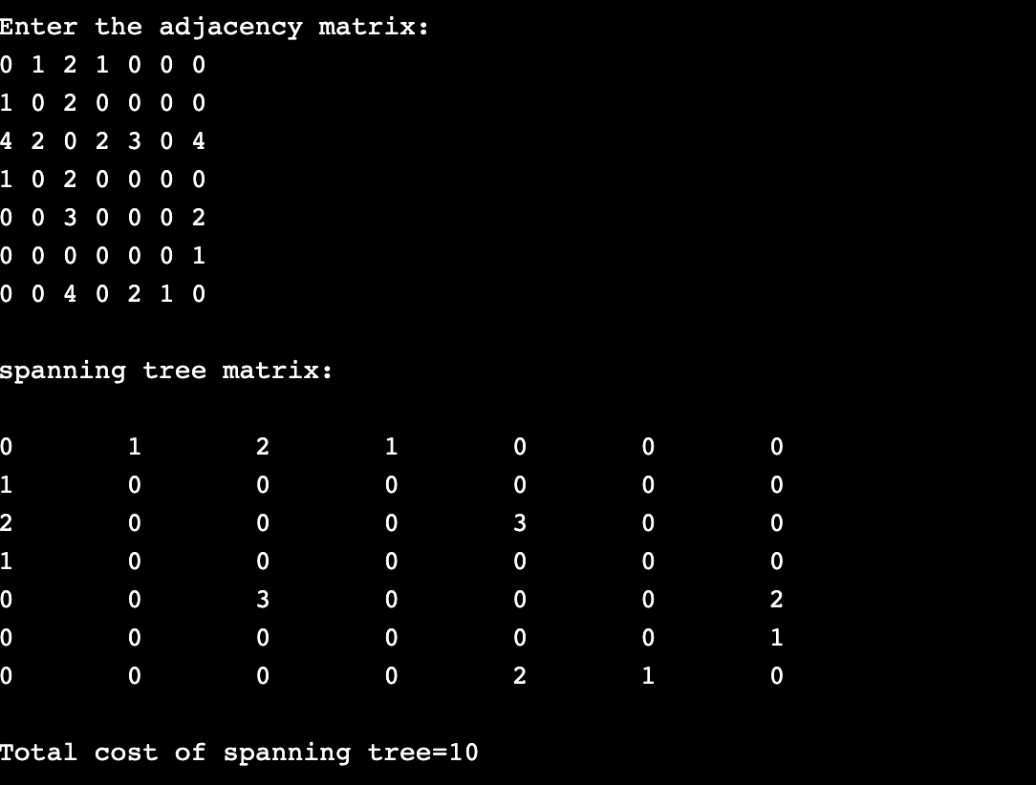

Q1). Show the order in which the vertices will be visited in a DFS and a BFS of the following graph. When you have a choice, visit the vertices in alphabetical order.

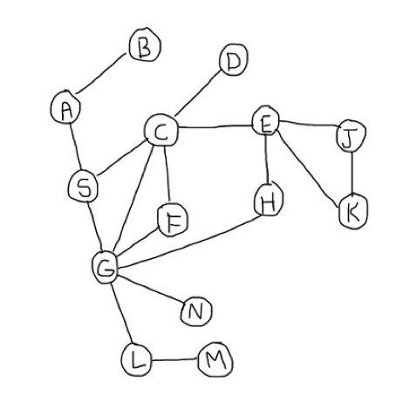

#include<stdio.h>

#include<stdlib.h>

typedef struct node

{

struct node *next;

int vertex;

}node;

node *G[20];

//heads of linked list

int visited[20];

int n;

void read_graph();

//create adjacency list

void insert(int,int);

//insert an edge (vi,vj) in te adjacency list

void DFS(int);

void main()

{

int i;

read_graph();

//initialised visited to 0

for(i=0;i<n;i++)

visited[i]=0;

DFS(0);

}

void DFS(int i)

{

node *p;

printf("\n%d",i);

p=G[i];

visited[i]=1;

while(p!=NULL)

{

i=p->vertex;

if(!visited[i])

DFS(i);

p=p->next;

}

}

void read_graph()

{

int i,vi,vj,no_of_edges;

printf("Enter number of vertices:");

scanf("%d",&n);

//initialise G[] with a null

for(i=0;i<n;i++)

{

G[i]=NULL;

//read edges and insert them in G[]

printf("Enter number of edges:");

scanf("%d",&no_of_edges);

for(i=0;i<no_of_edges;i++)

{

printf("Enter an edge(u,v):");

scanf("%d%d",&vi,&vj);

insert(vi,vj);

}

}

}

void insert(int vi,int vj)

{

node *p,*q;

//acquire memory for the new node

q=(node*)malloc(sizeof(node));

q->vertex=vj;

q->next=NULL;

//insert the node in the linked list number vi

if(G[vi]==NULL)

G[vi]=q;

else

{

//go to end of the linked list

p=G[vi];

while(p->next!=NULL)

p=p->next;

p->next=q;

}

}

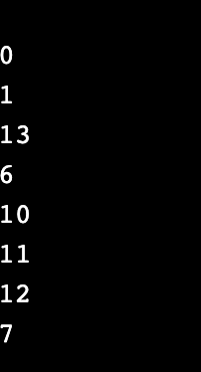

#include<stdio.h>

#include<stdlib.h>

#define MAX 100

#define initial 1

#define waiting 2

#define visited 3

int n;

int adj[MAX][MAX];

int state[MAX];

void create_graph();

void BF_Traversal();

void BFS(int v);

int queue[MAX], front = -1,rear = -1;

void insert_queue(int vertex);

int delete_queue();

int isEmpty_queue();

int main()

{

create_graph();

BF_Traversal();

return 0;

}

void BF_Traversal()

{

int v;

for(v=0; v<n; v++)

state[v] = initial;

printf("Enter Start Vertex for BFS: \n");

scanf("%d", &v);

BFS(v);

}

void BFS(int v)

{

int i;

insert_queue(v);

state[v] = waiting;

while(!isEmpty_queue())

{

v = delete_queue( );

printf("%d ",v);

state[v] = visited;

for(i=0; i<n; i++)

{

if(adj[v][i] == 1 && state[i] == initial)

{

insert_queue(i);

state[i] = waiting;

}

}

}

printf("\n");

}

void insert_queue(int vertex)

{

if(rear == MAX-1)

printf("Queue Overflow\n");

else

{

if(front == -1)

front = 0;

rear = rear+1;

queue[rear] = vertex ;

}

}

int isEmpty_queue()

{

if(front == -1 || front > rear)

return 1;

else

return 0;

}

int delete_queue()

{

int delete_item;

if(front == -1 || front > rear)

{

printf("Queue Underflow\n");

exit(1);

}

delete_item = queue[front];

front = front+1;

return delete_item;

}

void create_graph()

{

int count,max_edge,origin,destin;

printf("Enter number of vertices : ");

scanf("%d",&n);

max_edge = n*(n-1);

for(count=1; count<=max_edge; count++)

{

printf("Enter edge %d( -1 -1 to quit ) : ",count);

scanf("%d %d",&origin,&destin);

if((origin == -1) && (destin == -1))

break;

if(origin>=n || destin>=n || origin<0 || destin<0)

{

printf("Invalid edge!\n");

count--;

}

else

{

adj[origin][destin] = 1;

}

}

}

